BASH ASSESMENT

1.

#Ask the user for their name

echo what’s your name?

read name

echo “Welcome $name”

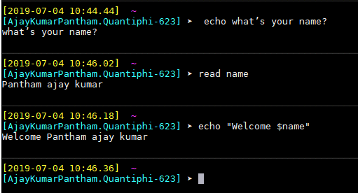

2.

echo enter the two numbers
read -p 'first number : ' a
read -p 'second number : ' b

let sum=a+b
let diff=a-b
echo sum= $sum
echo diff= $diff
